
http://www.westbeckenhamra.org

May 2013 Edition

The Review

You are invited to
WBRA AGM
to be held on Thursday 16th May
at 8.00pm at Beckenham Library
After the formal business, our speaker will be Cheryl Curr. Town Centre Manager.
Come and share a glass of wine and light refreshments!
(The Minutes of last year’s AGM are at the end of this newsletter, so do please bring your copy with you to the meeting.)

EDITOR’S INTRODUCTION – by Judith Niechcial

Welcome to the Spring edition of The Review, where, in addition to the usual local news, we have an exciting report of a bid to the Heritage Lottery Fund to create an on-line source for the history of Beckenham and Clock House.

Please do keep clicking on our website at http://www.westbeckenhamra.org/ for up-to-date news of local events and issues of interest, and items on local history. If you would like to know more about the Association or to publicise events of interest to members, email: info@westbeckenhamra.org.
HERITAGE LOTTERY FUND BID FOR HISTORY OF BECKENHAM / CLOCK HOUSE – by Marie Pender

WBRA, in collaboration with Copers Cope Area Residents’ Association (CCARA) have taken forward a bid to the Heritage Lottery Fund (HLF) to make the history of Beckenham, and in particular the Clock House district, available on line. More than 70 famous people have been connected with this area going back to 1740. Members will know we have many local historians who have published several books over the past decade, including WBRA members Cliff Watkins, Pat Manning and Ian Muir. This project will make much of their source material available online in a searchable manner. This rich heritage will be available to generations present and future through a website and virtual heritage trail. It will be accessible to people who would not normally, or who cannot, visit a library or museum (for those not “online”, most of it can be seen at Bromley Library). It will also provide this source material to local schools to use in Key Stages 2 and 3 in the History National Curriculum and encourage students to develop their own historical interests and seek out further sources for themselves. We aim to prioritise material from World War 1 in time for the centenary of its start in summer 2014.

We aim to scan historical documents such as the local street directories from 1885 to 1939 and a selection of The Beckenham Journal newspapers (particularly editions around WW1), photos from the Bromley Library and other archives, and selections of published books and souvenir programmes. The original historical sources of the directories and journals are either paper or film based and are in deteriorating condition. This project will preserve these original sources in electronic format from which readers can investigate the residents of past times and their own local history.

We also aim to include readings and dramatisations of Enid Blyton’s and other local authors’ and composers’ works, and oral histories from local people on their experiences of living in Beckenham, and 3D imaging of associated artefacts and buildings.

We have recently submitted a Project Enquiry Form to HLF and we await their opinion on whether we have put together a bid good enough to proceed to the next stage of a formal bid. In all, the project may cost around £60,000. No money will be needed from WBRA, apart perhaps from a small amount of around £100 a year to keep the new website licensed in about 5 years time.

MEMBERS’ EMAIL ADDRESSES

As we said in the last Review, it would be extremely helpful to able to contact members by email to tell you of local events and issues between Reviews. So far, fewer than 20 members have responded, so it has not been possible to use this as a normal communications route, though we have been able to communicate with some of this twenty on local issues. We will not use your email for any purpose other than contact between WBRA and yourselves and will not pass them onto any other organisation or individual.

If you would be willing to share yours, and have not already done so, would you please email mpenderwbra@btinternet.com with the heading “WBRA MEMBER EMAIL ADDRESS” and a message saying “I agree that WBRA may use this email address to contact me on WBRA issues and for no other purpose.”
Please don’t forget to give your name and address at the end so we know it’s you!
THE FUTURE OF THE BECKENHAM BEACON – by Peter Nazareth

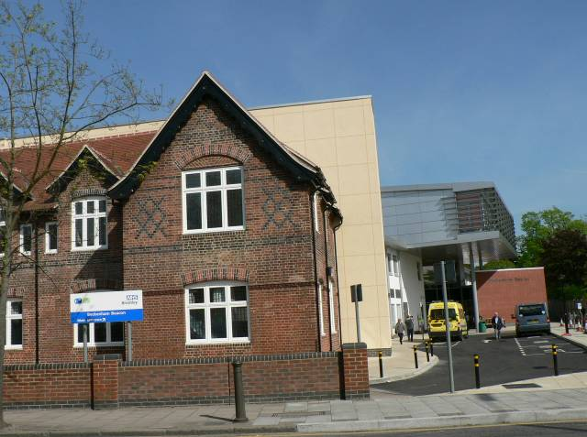

For the past few years, the South London Healthcare Trust (SLHT) has been operating The Beckenham Beacon where it provides a range of diagnostic and GP services and
urgent care for minor injuries, while utilising only some 45% of the available space (most of the rest of the space is used by other
providers including GPs). Now, the Secretary of State for Health, on the recommendation of
the Trust’s Special Administrator, has
wound up SLHT and so it cannot continue to provide these services.

As a result, Bromley’s Clinical Commission-
ing Group (CCG) is in discussions with Kings College Hospital to replace the SLHT and at the same time is looking at opportunities to expand and enhance the range of services available at The Beckenham Beacon for
local residents.

To this end, the CCG are establishing a Project Group to include representatives from the medical profession and the public. A Project Manager has already been appointed and one of the key objectives of the CCG will be to identify new services to be provided at The Beckenham Beacon and to engage with the local population and stakeholders in facilitating the provision of those services. WBRA will be represented on this group, whose first meeting was on 7 May and if you have any views you wish to feed in please send them to Marie Pender at the addresses (street or email) given on our committee sheet in this Review. It is hoped that the project will be completed by March 2014 and, as there is no contingency measure highlighted, they seem confident that their aggressive timetable is achievable.

The Beckenham Cottage Hospital, as it was known, was founded in 1872 by a group of local people supporting the initiative of Peter Richard Hoare of Kelsey Manor, and was established on the maxim that it is good to have a small hospital in the vicinity of people’s homes and in proximity to fresh air and green space. Throughout the years, from Cottage to General Hospital, the community has supported and developed this facility as a treasured local benefit.

Although the neighbouring green fields have long since disappeared, this now state-of-the-art local hospital retains its cottage charm and character of bygone days. I am struck by the floor polisher who hands out the tickets for the Blood Testing Centre at first light and his sense of compassion when he lets me in early on the odd cold morning. In the waiting room I am confronted by good humoured people, even on those occasions when someone on Warfarin is allowed to go ahead of the rest of us patiently waiting for our numbers to be called!

Long may The Beacon’s light continue to shine. To quote a local MP: “It would be criminal to shut it down”.
Look out for a full history of the Beacon researched by Alan Freeman in the next issue of The Review, in October 2013. Meanwhile you can read more on our website, address at the top of page 1. Ed.

LOCAL PRODUCE MARKET
Saturday 18 May, 10.00-4.00

Hurry - This sounds unmissable!


There will be real Kent food, drinks & crafts for sale on Beckenham Green. You will find juices, jams, chutneys, rare breed meats, free range poultry, sausages, sauces, bakery, organic fruit & veg and much more. There’ll also be entertainment, Morris Dancing and fair rides. The Market is organized by Copers Cope Area RA.

CRYSTAL PALACE PARK

On 23rd April the Crystal Palace Community Association put their challenge to the Master Plan for the park in front of three Lord Justices in the Appeal Court. The two remaining grounds on which the judicial review was permitted were rejected by the court and the legality of the Secretary of State's action in signing off the Master Plan was upheld. The Master Plan, therefore, stands and could be utilised immediately if Bromley Council is so minded, but it is unlikely they now have the necessary funds.

John Payne, Chair of CPCA commented that, despite the failure of the challenge to the Master Plan, the effort and cost of bringing the action has been justified because of the public interest and attention that has resulted.
Meanwhile WBRA understands that funding is in place for the work on the subway on the Southwark side of the Parade – planning permission is being sought from Southwark Council. Bromley Council has committed £50,000 towards an application to the Heritage Lottery Fund: Parks for People scheme. There are plans for a new visitor centre and café,
and features that the CPCA had suggested six years ago. There is fortunately no mention of the controversial luxury flats.

PLANNING NEWS – by Marie Pender

House of Multiple Occupation at Thayers Farm Road. This alarming application is for a change of use from light industrial to a house of multiple occupation (HMO, in the jargon). The address is formally 112 Beckenham Road, but it is the pink building which can be seen from Beckenham Road and access is from Thayers Farm Road. The proposal is for 17 bedsits with just two kitchenettes. The bedsits themselves are extremely small – most are less than 2 metres square. There is no provision for any communal areas such as a TV room. The plans are badly drawn and the floor plans do not match up with the elevations. There is no mention of who would own or run this establishment. This clearly poses social as well as planning development risks. Where would 17 people go to eat their meals or for any leisure?

HMOs are subject to licensing by the local authority. However, Bromley’s website has very little detail on licensing, and even states that it does not licence HMOs unless they are three storeys in height – this one is just two. In contrast, LB Croydon’s website has detailed information on their licensing requirements for various sizes of HMOs. Croydon specifies the ratios of rooms or people to toilets/ showers/ baths/ kitchen facilities. There is no such information on the Bromley website. For an HMO of this size, Croydon would require at least 4 showers, 4 separate toilets and a basin and drainage in each room where there are more than 6 people in the house. This proposal for 17 rooms has only 3 shower rooms, only one separate toilet, and the plans show no washing facilities in the rooms.

The previous application to demolish this building and build a five storey block of flats was refused and an appeal was dismissed. We understand that it might be difficult for the owner to find new tenants or develop the land, but this proposal surely must be beyond the limits of acceptability under any circumstances. Councillor Getgood has taken the matter up with the council officials on our behalf.

Barclays Bank Beckenham Road. In the last Review we reported that the application for two additional storeys to this building had been refused but Barclays had lodged an appeal. The appeal was also dismissed as the Inspector agreed with our objections that the extra height would make it far more prominent when seen from the west and that the flat roof would be at odds with the varied roof lines of its neighbours. A new application was submitted in February with the new floors stepped back further from the front of the building. We objected that, although this was a move in the right direction, the step back did not go far enough. However, the application was approved in April.

Manor Way. The application to demolish the bungalow behind Bailiff’s Cottage in Manor Way has been refused on the grounds that it would be a cramped overdevelopment of the site and thereby detrimental to the visual amenities, appearance and character of the Manor Way Conservation Area and adjoining statutory Listed Building. Also its height and proximity to neighbouring properties would have a seriously detrimental impact on the residential amenities of these properties and the prospect which the occupants of these dwellings might reasonably expect to be able to continue to enjoy. Finally, the development would prejudice the retention and well being of a protected beech trees which are protected by a Tree Preservation Order which makes an important contribution to the visual amenities of this part of the Conservation Area.

Car Park at New Beckenham Station. In the last Review we commented on the plans for an extension to the car park. The additional parking is to be located on the land between the railway line and the gardens at the Lennard Road end of Kings Hall Road. The plans are for permeable concrete and it is hoped that most of the existing trees will remain. Members have contacted us to say they were unhappy about the plans, which they feel will be detrimental to the area and will not deter street parking because of the high charges. We understand that there have been continued discussions with the council about the proposals and support members in their actions.

Kings School of English. Following the erection of the link between the two Victorian buildings, the school has obtained permission for a two storey side extension with front and rear dormer window extensions to provide accommodation in roof space; single storey outbuilding to rear for use as office, subject to 10 conditions including design and materials.
Rowden Works. WBRA continues to support members in Turners Meadow Way, Chaffinch Road and Rowden Road in opposing the new application. The removal of the second floor accommodation is welcome. However, this results in only a small reduction in overall height since the second floor was previously actually in the roof space. The bulkiness of the building is affected very little by the apparent removal of the second floor. The footprint remains the same. Therefore the Inspector’s conclusions in 2006, that the height and elongated mass of the development failed to reflect the character of the surrounding area, should still stand. We understand that the application is to be considered by the Development Control Committee.

KENT HOUSE STATION APPROACH

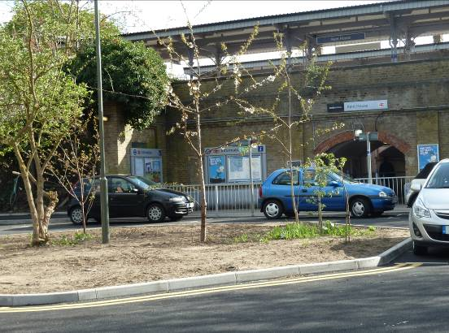

Recent Reviews have shown pictures of the quagmire that was Kent House Station Approach, and the last edition had a photo of works underway. The work is now complete, and is a great improvement. Some new trees have been planted and we now await some turf on the circular area outside the station. The crab apple trees are still too close together, but we are working on that! Committee member Shirley Civil has doggedly pursued this issue for over a year, and undertaken some ‘guerilla gardening’ to remove ivy from the existing trees.

BECKENHAM TOWN CENTRE

We will be pleased to welcome the new town centre manager, Cheryl Curr, to our AGM to talk about the plans for the town centre rejuvenation over the summer. Meanwhile, here is an update on the bid for Transport for London (TfL) money for a major overhaul.
Unfortunately the bid was unsuccessful this year because the fund was oversubscribed and LB Bromley already had funds for the Bromley North scheme. However, TfL have encouraged us to resubmit the bid for the next year and for this year they have allocated £200,000 towards the junction realignment at Southend Road/Rectory Road/Albemarle Road/High Street. This will help ease the movement of HGVs turning left from Rectory Road into Southend Road next to the station.
Meanwhile LB Bromley have allocated around £40,000 for short term projects to help the town centre revive itself.

Come to the AGM to find out more from Cheryl Curr

POLICE

The Borough Commander, Steph Roberts has circulated a newsletter, giving, among other things, news of two recent police operations. She writes:

‘Big Wing’ nets 30 in Bromley
30 people were arrested across Bromley in Operation Big Wing at the end of February, with nine uninsured vehicles
also being removed from the borough’s roads. The arrests were for theft, motor vehicle crime, robbery, domestic violence, assault, harassment, drugs, handling stolen goods, absconding from prison, immigration offences, weapon offences, criminal damage, driving whilst
disqualified and breach of ASBO. The operation was so successful that Bromley's Custody Suite was full at one stage in the day.
Drugs, stolen goods and a stolen motor vehicle have been recovered during the raids and officers arrested a man on suspicion of absconding from prison after he was found hiding in a loft at a house in Beckenham. Officers also raided a cannabis factory and seized 80 plants.
Op ‘Hawk’ nets 26 arrests across borough
A major Police offensive against street level drug dealing and cannabis farms led to the arrest of 26 people across Bromley on 27th March. 16 raids took place throughout the day as hundreds of Safer Neighbourhood officers, supported by specialist colleagues, set to work to execute drugs warrants in direct response to community intelligence. Cannabis factories were found at several addresses in Orpington, the Crays and Biggin Hill.

NB
The phone numbers for the Safer Neighbourhood Offices for our area are:
Penge and Cator – 07843 065 880
Clock House – 07920 223 847

ALSO
Included with this edition you will find a sticker to put in your window to deter rogue traders issued by Bromley Trading Standards.

CLOCK HOUSE PARADE SHOPS – by Marie Pender

This fine parade of shops was built in 1904 by local builders Syme and Duncan Ltd. It is very sad to see its present condition with just five of the thirteen shop premises occupied. In March, Marie Pender met with Cllr Sarah Phillips and Martin Pinnell of the Town Centre Management and Business Support Team of the council, and local businesses to discuss what can be done to encourage its rejuvenation.

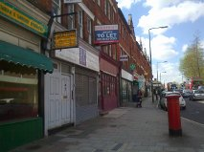

The terrace is owned by one person, who does not live locally. The parade is managed through an agent. Possible actions that could be funded through the council’s Local Parades Initiative include a general tidying up round the bus stop, improved lighting, a promotional campaign, vinyls for the empty shop windows, pop up shops, planters or hanging baskets and signage on the parade’s history. The area is already quite busy with Beckenham Library and Spa opposite and when the new community premises (formerly known as “The Studio”) open, more people will be using the area and the road will have a much more open feel when the green hoardings are taken down.

ELMERS END HISTORY EXHIBITION

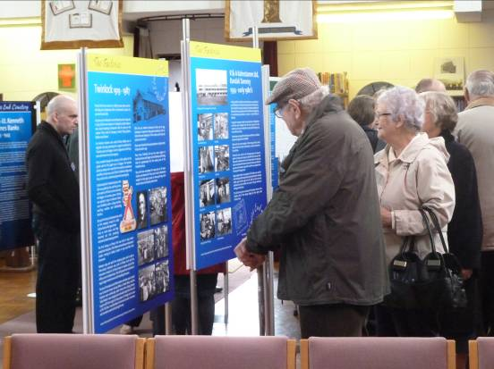

This free exhibition, held at Elmers End Free Church on 13 – 14 April was very well attended, and was fascinating. There were stands illustrating different aspects of the local scene, the old farms that provide so many current place names, the railways, the factories, the schools, the pubs, and one about the famous people buried in the Cemetery, (see The Review of May 2012 for more about that.) including the diver who saved Winchester Cathedral.

THE STUDIO

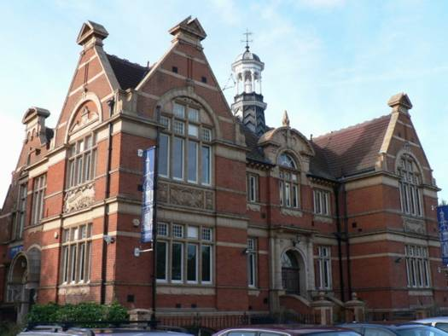

Despite our hopes that this iconic building, now known as 28 Beckenham Road, would be open in January this year, this has not happened, and so we cannot use this venue yet for our meetings, but we still hope to do so in the not to distant future, and that Citygate Church, the owner, will soon open it up to community use.

"MARCH OF THE WOMEN"

This concert at St George's Church, Beckenham on 9 March, organised by Cliff Watkins, celebrated Beckenham's women and raised over a thousand pounds for St Christopher's Hospice and Woodlark Campsite Trust.

CENTENARY OF THE JEWEL OF BECKENHAM – KELSEY PARK
- By Peter Nazereth

By special decree the public were allowed into the Kelsey Estate to celebrate the coronation of King George V. In 1908 Tom William Thornton (1857 – 1933) secured most of the land against housing development (yes, we had developers even then), and lobbied the local council to create a park which officially opened on 31 May 1913. Thanks to his vision we have today a park of outstanding beauty adorned by lakes, waterfalls, wildlife and other attractions cared for by experts and volunteers for the enjoyment of the public.

To commemorate his gift and great achievement a small plaque dedicated to T W Thonton can be found just inside the Court Downs Road / Kelsey Park Road entrance gates.

The Friends of Kelsey Park will be hosting celebrations during May and June to mark this Centenary. Information about these events will be posted on notice boards in the Park and in the newly opened Information Centre which is open between 14:00 and 16:00 at weekends. We will also post news about the celebrations on our website. It will be an appropriate time to look back and remember the efforts of people behind the scenes.

THE GHOST AT BIRKBECK STATION & OTHER TERSE VERSE

Our redoubtable President, Janet Ambrose, has recently published a slim volume of her collected poems. It is full of local interest, and versification of Janet’s many and various concerns. Some of these have been previously published in The Review, but they are well worth reading afresh. The book is available from Janet, whose contact details are at the end of this Review. Here is one on her memories of WW2.

Doodlebugs
I well remember the chug-a-chug-a-chug-a-chug
Of an approaching doodlebug.
It sent us running helter-skelter
Down the garden to our shelter.
Where we crouched with hands clamped to our ears
Trying to suppress the fears
Of secret weapon up on high
Somewhere above us in the sky.

Then silence …as the noise cut out
Fifteen seconds – or there about
Fifteen seconds with terror filled
Would it land on us – would we be killed?
Then booohm! We ran out with relief
To see who may have come to grief
And watch with awe the huge black cloud
Expanding – like a funeral shroud.
Now there’s no more bombs, no more time in the shelter
We can safely sleep – there’s no more helter skelter.
There’s no more leaving our warm beds at night,
No more spoilt meals, not more ‘put out that light.’
Oh Joy! No more bombs and even today
Some seventy years on and I still feel that way.

CITIZENS ADVICE BUREAUX

The well-appointed CAB in Snowdown Close, Penge has also closed. In its place we now have a drop in CAB service operating at:
- Anerley Town Hall, Mon & Weds 10-12
- Christ Church, Maple Road, Mon.10-1.00
- Holy Trinity, Lennard Road, Mon & Fri, 10-1.00.
Telephone enquiries can be made at the Bromley Office on 020 8315 1940.

UPCOMING EVENTS - by Alan Freeman

Giles de la Mare, a relative of the poet, will be giving a talk and reading ‘The Listener’ and other poems at Holy Trinity Church, Lennard Road on 31 May at 7.30

There will also be a walk taking in the number of streets and houses where the poet lived in in Beckenham and Penge on 1 June at 10.00am. Meet outside the Moon & Stars pub on Penge High Street.

A heritage walk will start from Alexandra Nursery garden centre in Parish Lane, Penge on Saturday 25 May at 2.00pm. Walkers will be able to buy plants etc at a 10% discount.

The Friends of Alexandra and Cator Parks are having a ‘Bat Walk’ on 4 June. Meet in Cator Park at 8.00, and bring a torch.

